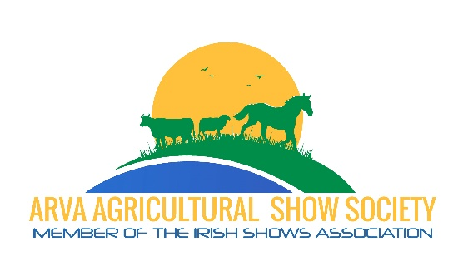
Tender for Catering Franchise 2025
Offers are invited for the Catering Franchise for Hot food at the Arva Agricultural Show which will be held in the Arva Show Field, Arva, Co. Cavan on Sunday 27th July 2025.

Rules & Conditions
- The catering franchise will be for 1 year only.

- The caterer awarded the franchise will have exclusive rights to provide hot food (with a various selection of foods, including gluten free option) for the general public attending the show, on a good day with attendance of around 3000-4000 visitors. The exception to this rule will be other small food outlets selling crepes, and sweet treats.

- At least 2 food units will be needed on the Show Field. One of these units should have seated areas with tables and chairs where the public can eat. The food units will be located on the Show Field as directed by the organising committee.

- If sub-contracted food units are to be located on site, the identity of the owners of these units must be made known to the Show Committee on application and the rules applying to the principal caterer will also apply to these units.

- All food outlets must be registered by the Food Safety Authority of Ireland (FSAI). The registration documentation must accompany this application and must be made available for examination by the organising committee each year before the units move to the site.

- All staff handling food must have received appropriate hygiene training as per Food Safety Authorisation of Ireland (FSAI) guidelines. It is also recommended that adequate HACCP Principles are in place. Hand-Washing facilities must be provided at each unit.

- All food units on site must carry full Public/Product Liability Insurance to the value of at €2,600,000.
A copy of your Public/Product Liability Insurance certificate must accompany this application.

- The prices charged for food on Show Day must be prominently displayed for the public by each retail food unit. The price list of the foods to be sold on Show Day must be submitted along with this application. These are the prices which must be charged on Show Day.

- The highest bid offered for this franchise may not necessarily be the one accepted as a number of factors must be taken into consideration. The decision made by the Show Committee in awarding the contract will be final and no discussion or correspondence will be entered into with applicants.

Tender for Catering Franchise Application Form 2025

Amount Offered for Catering Franchise € .
(If this tender is accepted, 50% of the total amount must be paid in full on 1st July, and remainder to be paid on Show Day)

I agree to comply with all the rules and conditions listed.
(Tick Box): Yes No

Name

Company Name

Address

Contact Details

Email

This form, along with other relevant documents, must be returned to the Show Secretary (secretary@arvashow.com) on or before Wednesday 25th June 2025

Signed: ____________________________________ Date: ________________

